**DECLARATION**

THE TRAGEDY OF FLIGHT: A COMPREHENSIVE CRASH ANALYSIS

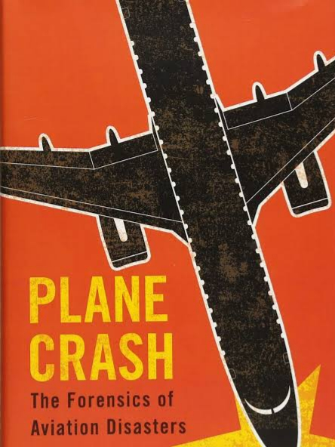

I, Miss **SASMITHA.K.T - REG NO: 2132K0270 ,** hereby declare that the project entitled **“DATA ANALYSIS AND VISUALIZATION FOR CRIME AGAINST WOMEN IN INDIA”** submitted to **Bharathiar University**, in partial fulfillment of the requirements for the award of the degree of **MASTER OF SCIENCE IN COMPUTER SCIENCE** is a report of original research work done by me during the period of study in **TIRUPPUR KUMARAN COLLEGE FOR WOMEN, TIRUPUR** under the guidance of **Dr.S.RADHIMEENAKSHI M.C.A.,M.Phil.,Ph.D., Associate Professor, PG & Research Department of Computer Science,** and I assume that this work has not been submitted to any other university for any other degree.

**PLACE:** TIRUPUR **Signature of the Candidate**

**DATE:**  SASMITHA.K.T

(REG NO: 2132K0270)

The Tragedy of Flight: A Comprehensive crash analysis

The Tragedy of Flight: A Comprehensive crash analysis

The Tragedy of Flight: A Comprehensive crash analysis

SUBMITTED BY:

TIRUPPUR KUMARAN COLLEGE FOR WOMEN

DEPARTMENT OF MATHEMATICS

III B.SC.MATHEMATICS WITH COMPUTER APPLICATION

|  |  |
| --- | --- |
| **TEAM ID** | **NM2023TMID11122** |
| **TEAM LEADER** | **1.S.VARSHINI** |
| **TEAM MEMBER** | **2.R.ANUSHUYA** |
|  | **3.S.BARKATH NISHA** |
|  | **4.RAMYA J SHANKAR** |
|  | **5.M.SUVETHA** |
| **TEAM MENTOR** | **Mrs.M.KAVITHA** |

|  |  |  |
| --- | --- | --- |
| **CHAPTER NO.** | **CONTENT** | **PAGE NO.** |
| **I** | **INTRODUCTION**   * 1. **OVERVIEW**   2. **PURPOSE** | **4** |
| **II** | **PROBLEM DEFINITION AND DESIGN THINKING**  **2.1 PROBLEM STATEMENT**  **2.2 BUSINESS REQUIREMENT**  **2.3 SOCIAL IMPACT**  **2.4 LITERATURE SURVEY**  **2.5 REFERENCES**  **2.6 EMPATHY MAP**  **2.7 BRAISTROMING MAP** | **5** |
| **III** | **RESULT**  **3.1** DATA COLLECTION &EXTRACTION  **3.2 SQL**  **3.3 TABLEAU**  **3.4 TABLEAU VISUALISATION** | **9** |
| **IV** | **ADVANTAGES AND DISADVANTAGES**  **4.1 ADVANTAGES**  **4.2 DISADVANTAGES** | **16** |
| **V** | **APPLICATIONS**  **5.1 APPLICATIONS** | **18** |
| **VI** | **CONCLUSION**  **6.1 CONCLUSION**  **6.2 FUTURE ENHANCEMENT** | **18** |
| **VII** | **APPENDIX**  **7.1 LINKS** | **19** |

**TABLE OF CONTENT**

1. **INTRODUCTION**

**1.1 OVERVIEW**

An airplane crash analysis is a detailed investigation into the causes of an aviation accident. The goal of an airplane crash analysis is to identify any factors that contributed to the accident, with the ultimate goal of improving safety and preventing future accidents. The process of conducting an airplane crash analysis typically involves the collection and analysis of a wide range of data, including information about the aircraft and its systems, the operators, and any other relevant factors. This data is typically collected from Kaggle. Once the data has been collected, it is analysed through tableau, to identify any potential causes of the accident. The results of an airplane crash analysis are typically published in a report, which may include recommendations for improving safety and preventing similar accidents in the future. These recommendations may be implemented by the relevant authorities or industry organizations.

**1.2 PURPOSE**

This analysis provides insights in observing the trend of airplane crash over the years. It shows the percent of fatalities observed due to the crash. The analysis also help in determining which airline operator and types are worst to fly with. We also observe the top 10 countries which we should avoid to escape the crash. All these topics will be addressed and analysed.

**To effectively discover the hazards that led to the accident and to prevent their recurrence in a future accident or incident**. In the course of that investigation, additional hazards which increased damage and injury (inadequate crashworthy systems, system safeguards, rescue team response, etc.)



1. **PROBLEM DEFINITION AND DESIGN THINKING**

**2.1 PROBLEM STATEMENT**

This exploratory data analysis of the airplane crash data analyses the crash trend for over 100 years beginning from the year 1908 to 2008 from [www.kaggle.com](http://www.kaggle.com). It is particularly interesting to observe the trend of airplane crashes and the reasons behind them, as air travel is the one of the most common transport medium these days. It is also important to examine our progress in overcoming the crashes.

**2.2 BUSINESS REQUIREMENT**

Aircraft crashes are fundamental to weather (thunderstorm, strong winds, etc.), pilot error, etc. There is a necessity to study these issues. The study helps to understand who all are suffering, what is the reason for the crash and what harm is it causing to the general population and how can we prevent them. The crashes may cause loss of human life as well as loss of natural resources. Finding designs in the aeronautical data physically is impracticable because of the mass measure of data delivered each day. This vast amount of data can be analysed and measured using various computing techniques.

**2.3 SOCIAL IMPACT**

Aviation accidents cannot be 100% avoided, but it is possible to minimize the loss associated with accidents such as by reducing social panic. Aside from aviation disasters, terrorist attacks and economic crisis also affect aviation market performances. The most direct and immediate effect that we can see after accident occurring is stock price fluctuation. Stock market reaction is a suitable connection to understand passenger choice behaviour.

**2.4 LITERATURE SURVEY**

“Flight Crash Investigation Using Data Mining Techniques”. The research work is done for identifying aboard/ground fatality rate with operators and location as well as to find similarity among the plane crashes. Analysing relationships between aircraft accidents• and incidents. In proceedings of the international conference on research in air transportation. In this research he employed a data mining technique to conduct the holistic analysis of aircraft incident data in relation to the accident data. The analysis identifies the relation between the accident and incident data and finds the patterns of casual and contributory factors which are significantly associatively with the aircraft accident. Improvement of aircraft accident investigation• through expert systems. In this research presented in this paper shown that expert system methodology is a robust approach to analysing the aircraft accident investigation.

**2.5 REFERENCES**

Nazeri, Z., Donohue, G., & Sherry, L. (2008). Analysing Relationships Between Aircraft Accidents and Incidents. In Proceedings of the International Conference on Research in Air Transportation.

Milosovski, G., Bil, C., & Simon, P. (2009). Improvement of aircraft accident investigation through expert systems. Journal of Aircraft, 46(1), 10-24.

**2.6 EMPATHY MAP**

[**https://drive.google.com/file/d/1T3vDG08GtcmGNrZc26oI2ZvVQXgWkkbZ/view?usp=share_link**](https://drive.google.com/file/d/1T3vDG08GtcmGNrZc26oI2ZvVQXgWkkbZ/view?usp=share_link)

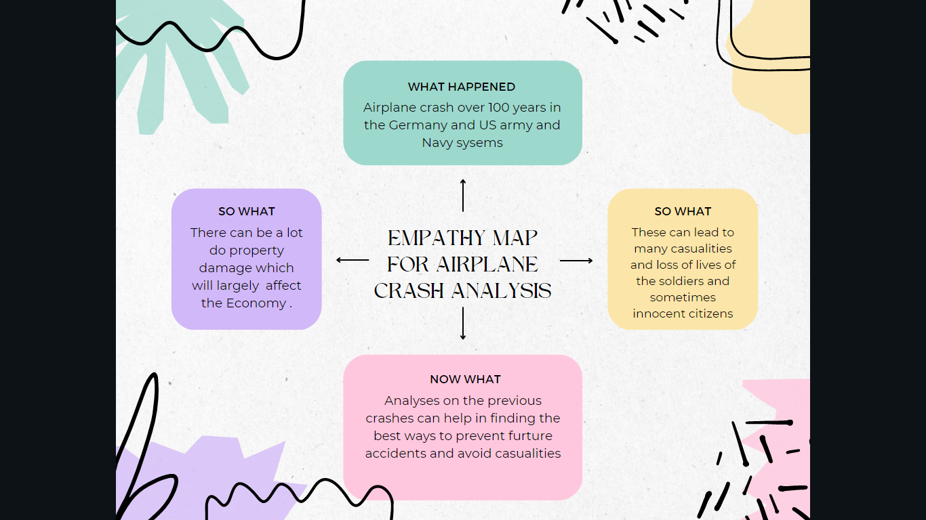

**2.7 BRAINSTROMING MAP**

[**https://drive.google.com/file/d/1SrEhP8il_33CE52NwCMbRcxBgyCQI8NU/view?usp=share_link**](https://drive.google.com/file/d/1SrEhP8il_33CE52NwCMbRcxBgyCQI8NU/view?usp=share_link)

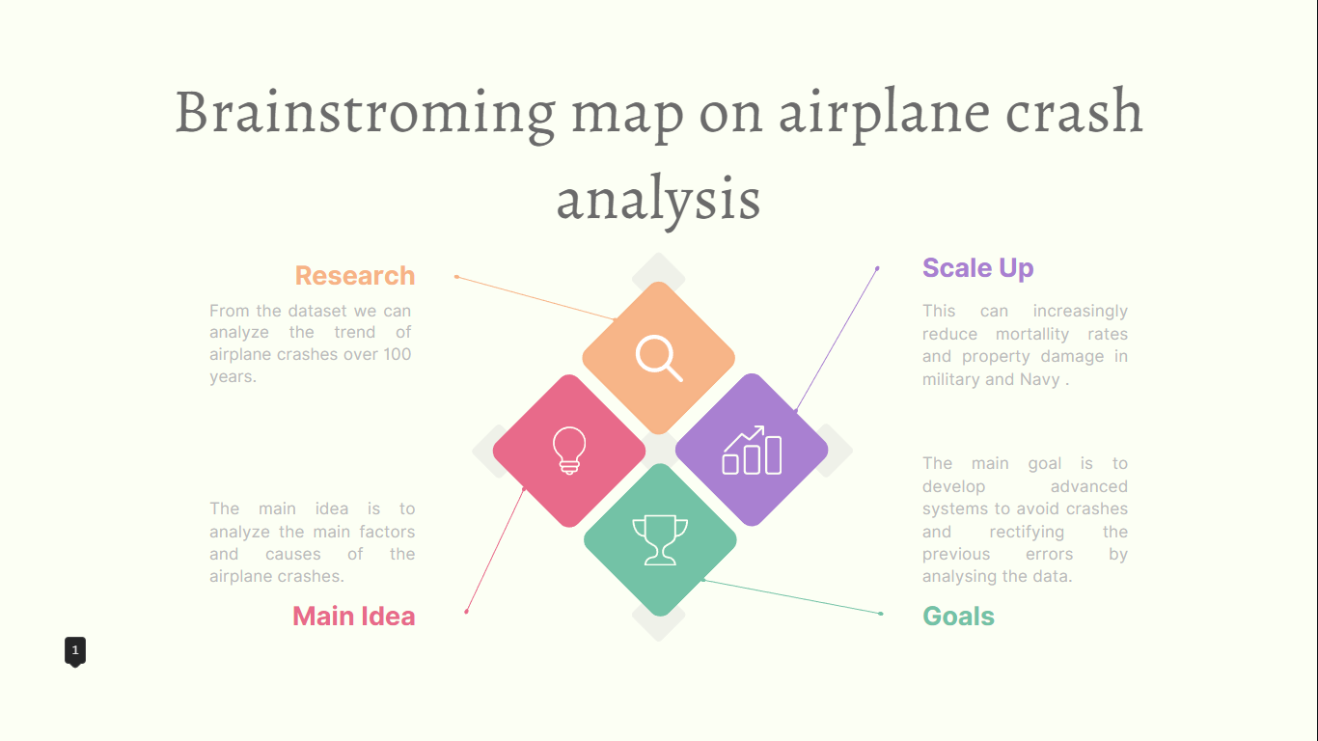

1. **RESULTS**

**3.1 DATA COLLECTION , DATA EXTACTION & DATA VISULIZATION**

**DATASET:**

* [**https://drive.google.com/file/d/1TZAT28uvW6vew3EzdrIsGE8_qPsuNS6/view?usp=share_link**](https://drive.google.com/file/d/1TZAT28uvW6vew3EzdrIsGE8_qPsuNS6/view?usp=share_link)

**UNDERSTANDING THE DATA:**

In dataset consumption .csv data in the form of a World population by age 2020. The Column of the dataset contains:

* Location
* Date
* Time
* Operator
* Type
* Flight#
* Registration
* Cn/in
* Aboard
* Ground
* Summary

**STORING DATA IN DB & SQL OPERATIONS:**

**3.2 SQL**

**CREATING SCHEMA**

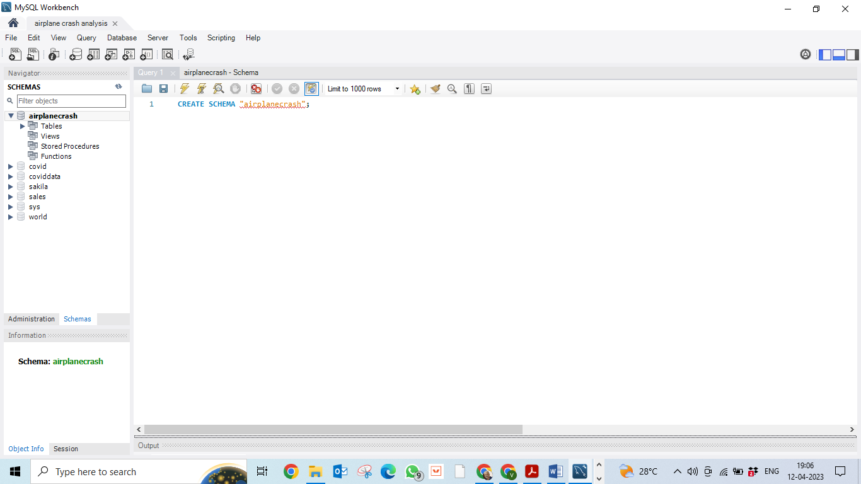

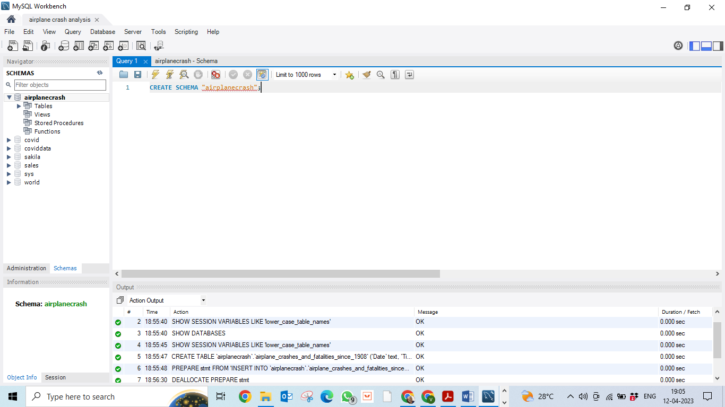

**SELECTING THE COLUMNS**

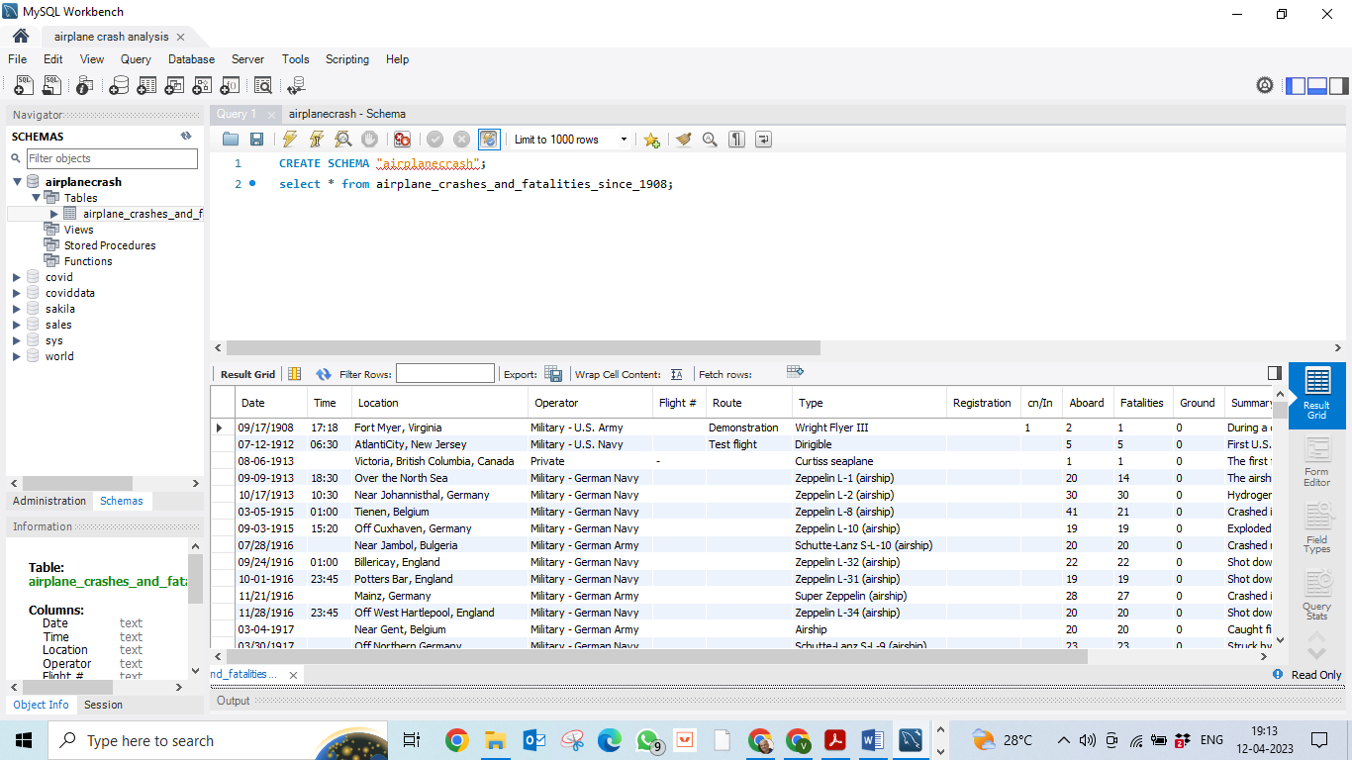

**3.3 TABLEAU**

**INSTALLATION**

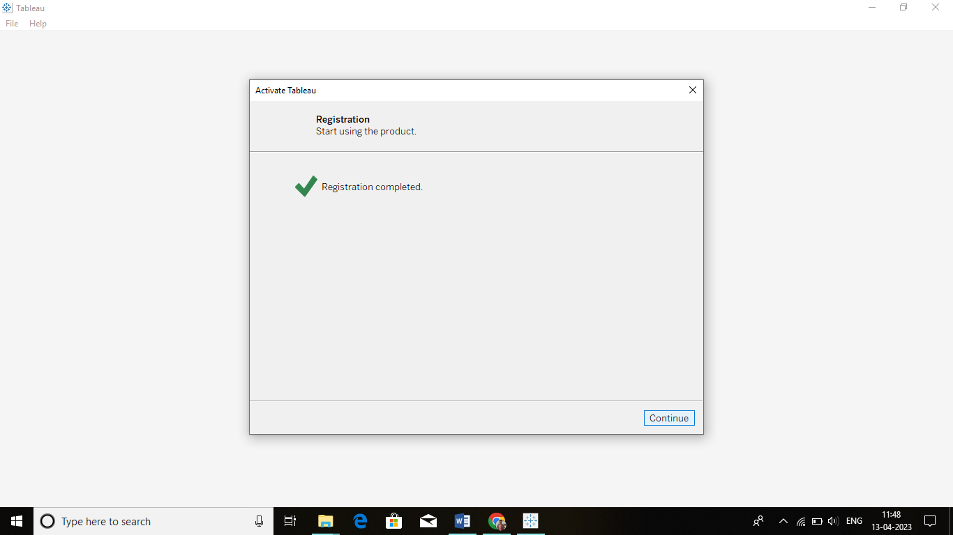

**DEFAULT WINDOW**

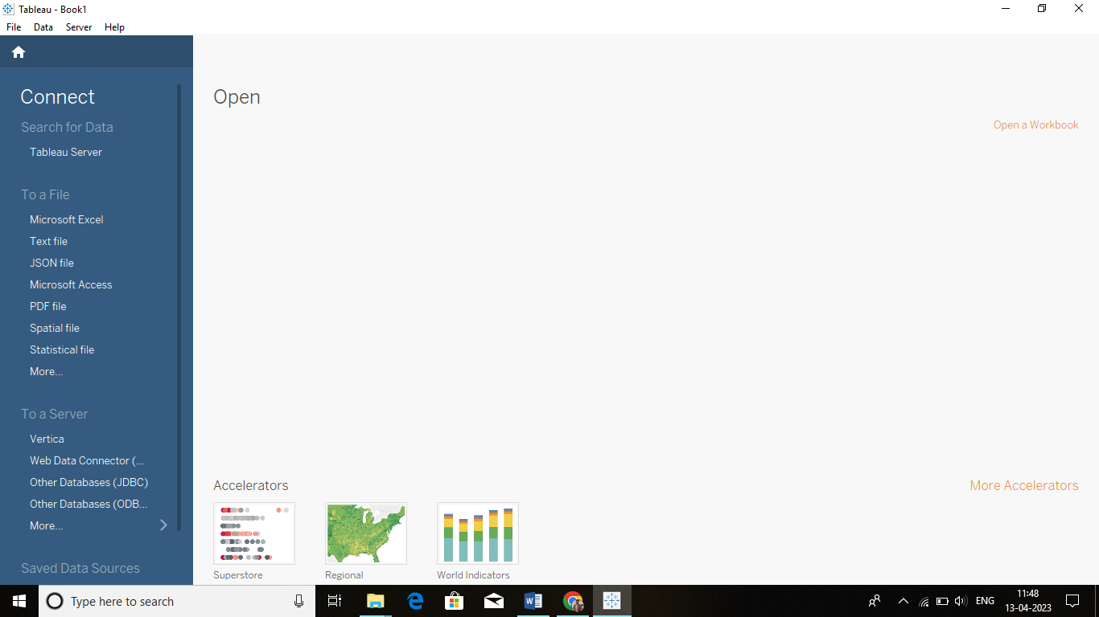

**3.4 TABLEAU VISUALISATION**

**LODING THE DATA**

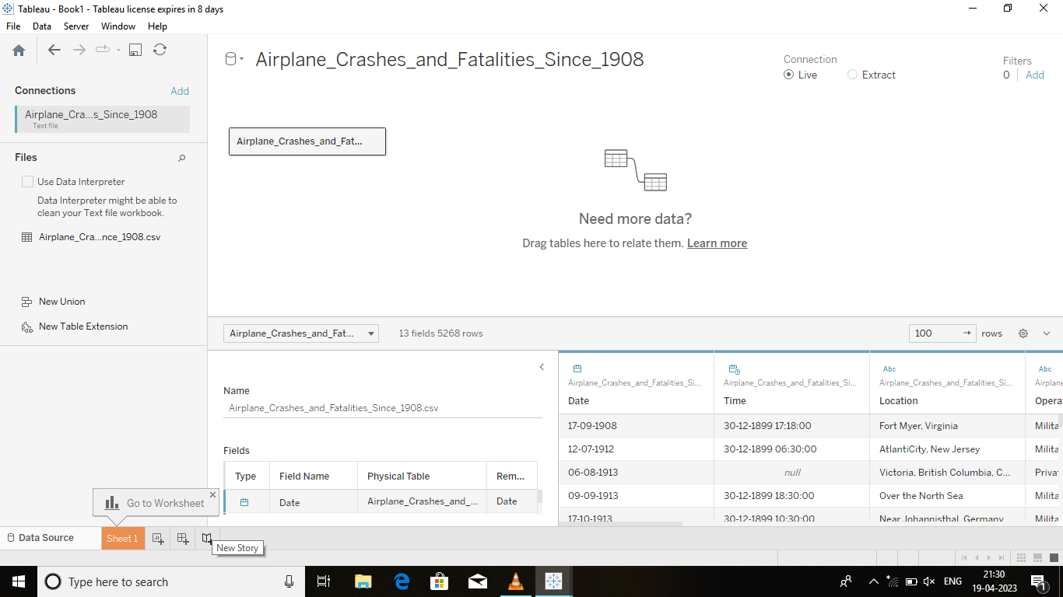

**TOP 10 COUNTRIES WITH HIGHEST FATALITIES**

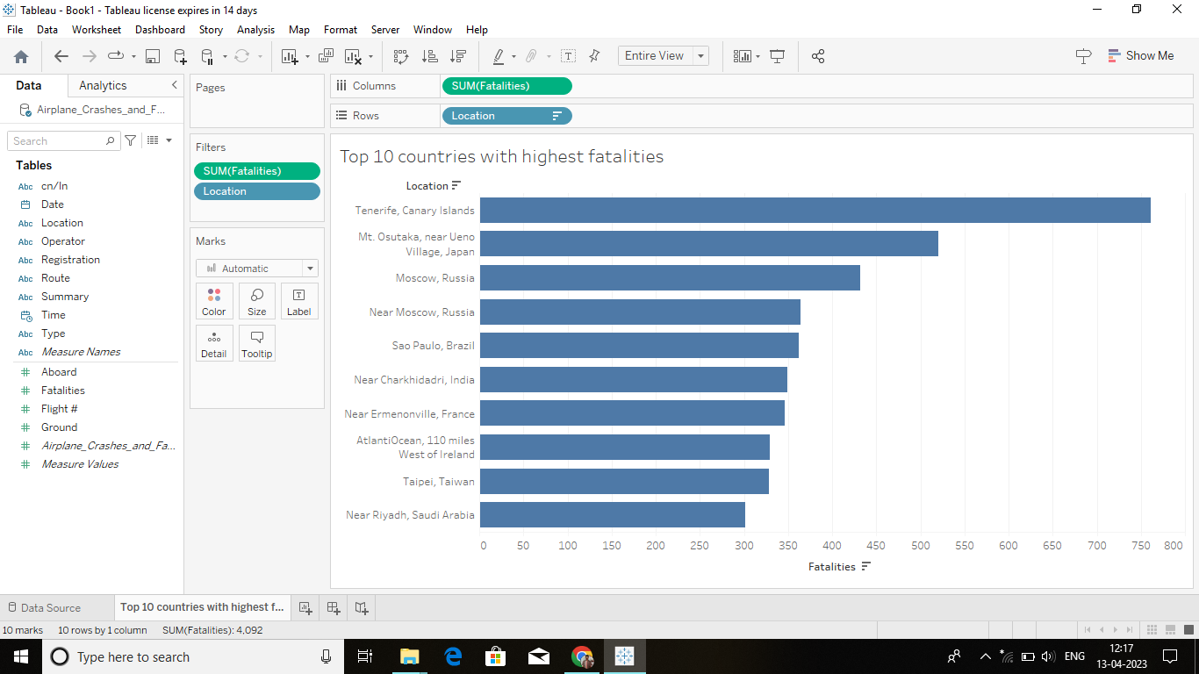

**TREND OF ACCIDENTS OVER YEARS**

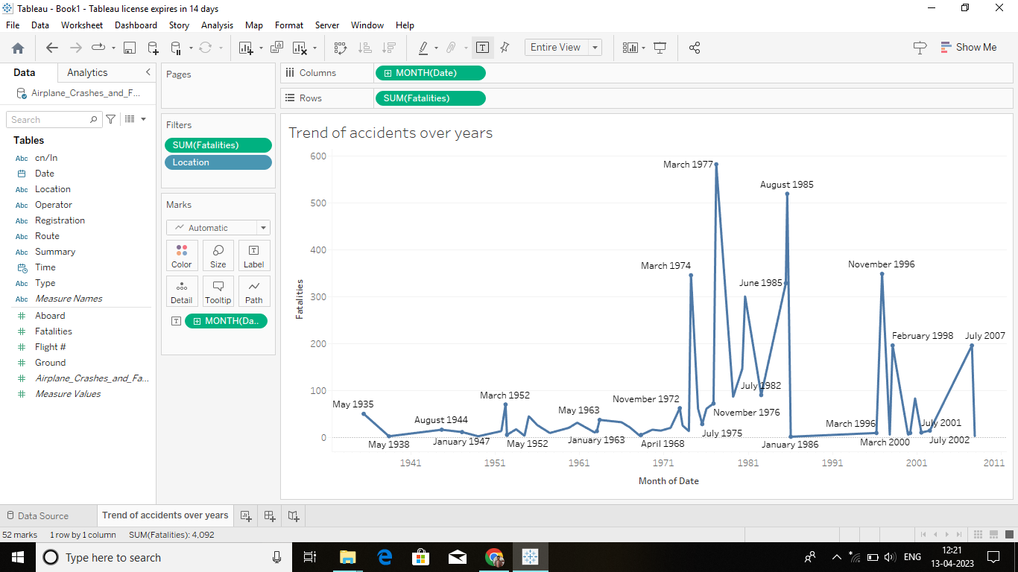

**TIME AND DATE WITH MOST ACCIDENTS**

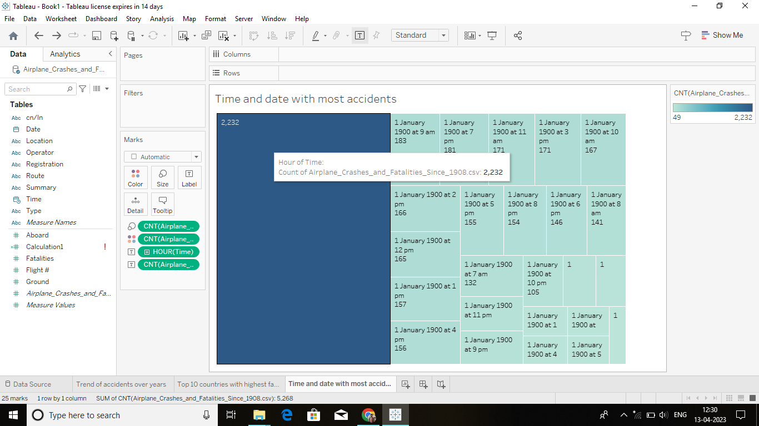

**TOP 10 ACCIDENTS LOCATIONS**

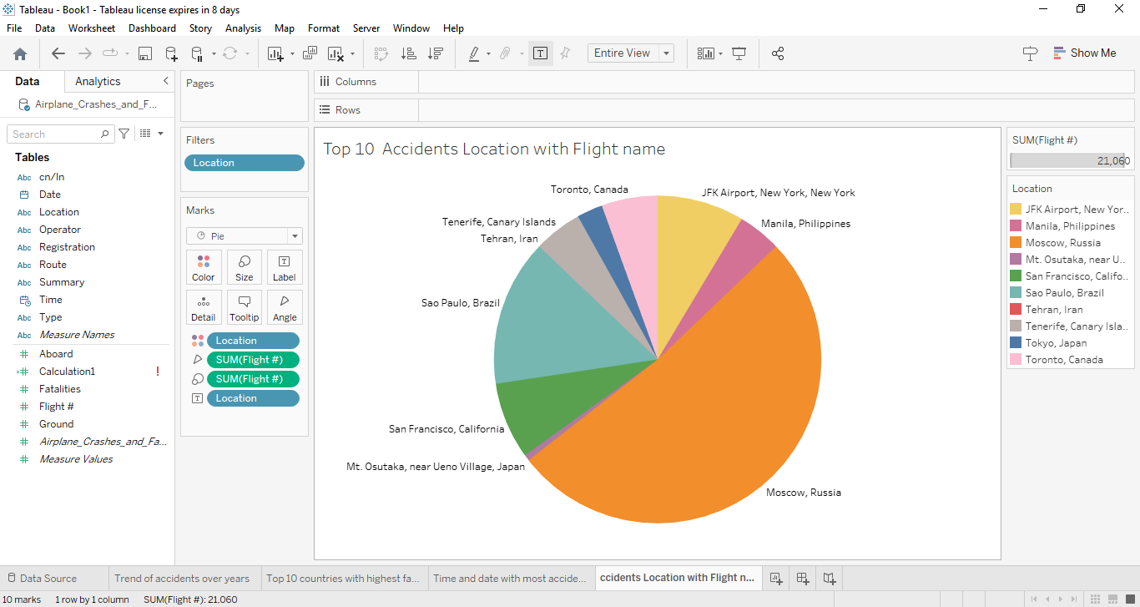

**TABLEAU LINKS:**

**TABLEAU WORKBOOK:**

<https://drive.google.com/file/d/1Z4eAkAprdSfBK9xFqkI1VPIlonb1lvA/view?usp=sharing>

**TABLEAU DASHBOARD:**

<https://drive.google.com/file/d/1LignzL-yyuis5bJNYBo84IAeknAaGwDc/view?usp=share_link>

**TABLEAU STORYBOARD:**

<https://drive.google.com/file/d/1Hk04VvooyWInX7eWpA3JYoR7IvLZRy9F/view?usp=share_link>

1. **ADVANTAGES AND DISADVANTAGES**

**4.1 ADVANTAGES**

* Increases passenger comfort;
* Improved flight path control and reduced weather minima;
* Systems monitoring displays coupled with diagnostic assistance systems ([Electronic Centralized Aircraft Monitor (ECAM)](https://www.skybrary.aero/index.php/ECAM)/[Engine Indicating and Crew Alerting System (EICAS)](https://www.skybrary.aero/index.php/EICAS)) support enhanced pilots’ and maintenance staff’s understanding of aircraft system states. However, when faced with a complex failure event, such as the [Airbus 380 engine break-up after take off from Singapore (2010)](https://www.skybrary.aero/index.php/A388,_en-route_Batam_Island_Indonesia,_2010), the normally ‘simple to understand’ failure information can swamp the crew and either hinder diagnosis or distract the crew from the principle task of FLY THE AIRCRAFT;
* Automation can relieve pilots from repetitive or non-rewarding tasks for which humans are less suited, though it invariably changes the pilots’ active involvement in operating the aircraft into a monitoring role, which humans are particularly poor at doing effectively or for long periods. As an example, pilots who invariably fly with Autothrottle (AT) engaged can quickly lose the habit of scanning speed indications. Therefore, when the AT disengages, either by design or following a malfunction, the pilots will not notice or react to even large speed deviations. ([Amsterdam B737-800 in 2009](https://www.skybrary.aero/index.php/B738,_vicinity_Amsterdam_Netherlands,_2009))
* Good automation reduces [workload](https://www.skybrary.aero/index.php/Pilot_Workload), frees attentional resources to focus on other tasks but the need to ‘manage’ the automation, particularly when involving data entry or retrieval through a key-pad, places additional tasks on the pilot that can also increase pilot workload. In contrast, poor automation can reduce the operators’ situational awareness and create significant workload challenges when systems fail.

**4.2 DISADVANTAGES**

* Basic manual and cognitive flying skills can decline because of lack of practice and feel for the aircraft. This is exacerbated if operators actively discourage flight crew from manual flying or limit the manual modes they may use – e.g. prohibiting manual flying with Auto-Throttle disengaged;
* Unexpected automation behavior uncommanded disengagement caused by a system failure resulting in mode reversion or inappropriate mode engagement by the pilot may lead to adverse consequences;
* Pilots interacting with automation can be distracted from flying the aircraft; selection of modes, annunciation of modes, flight director commands may be given more importance than values of pitch, power, roll and yaw and so attending to automation can distract the flight/crew pilots from monitoring flight path;
* Flight crews may spend too much time trying to understand the origin, conditions, or causes of an alarm or of multiple alarms, which may distract them from other priority tasks and from flying the aircraft;
* Diagnostic systems are limited with regard to dealing with multiple failures, with unexpected problems and with situations requiring deviations from Standard Operating Procedures ([SOPs](https://www.skybrary.aero/index.php/SOP));
* For highly automated aircraft, problems may occur when transitioning to degraded modes (e.g. multiple failures requiring manual or less automated flight);
* Data entry errors (either mistakes or typing errors) made when using Electronic Flight Bags ([EFBs](https://www.skybrary.aero/index.php/EFB)) in addition to avionics systems may have critical consequences; errors may be more difficult to prevent and detect as there is no system check of the consistency of the computed or entered values and technology gives a certain sense of confidence (if the data entered in the machine are accepted, they should be OK);
* In critical situations following disconnection or failure of the automation, the alarm system only indicates the condition met but not the action to take (although the action that the flight crew must take to regain control is known);

1. **APPLICATIONS**

**5.1 APPLICATION**

1. This will help the professionals to know the cause of the accidents and take necessary precautions to prevent further such events.

2. This analysis will also help them develop technologies and systems to estimate and reduce the occurrence of some minor causes and fix it.

3. Aviation accident analysis is performed to determine the cause of errors once an accident has happened. In the modern aviation industry, it is also used to analyse a database of past accidents in order to prevent an accident from happening.

1. **CONCLUSION**

**6.1 CONCLUSION**

The prediction of the system helps the user in taking the necessary precautions to prevent the mishap or any airplane crashes. The administration department thus becomes aware of the possible difficulties and hurdles that might come along the way. As a result, the elementary steps taken will help to eradicate any crashes that might occur thus leading to minimize the loss of property and life.

**6.2 FUTURE ENHANCEMENT**

The system is able to predict whether the airplane will be be“safe” or not. As a result, the delays of every airplane can alsobe predicted. The period after which an airplane has to gounder the maintenance stage can also be included with the system. Hence, the system will be the one stop destination to check the flight delays, airplane crashes and the period after which the flight should undergo the maintenance phase.

1. **APPENDIX**

**7.1 LINKS:**

* **DATASET:**
* [**https://drive.google.com/file/d/1TZAT28uvW6vew3EzdrIsGE8_qPsuNS6/view?usp=share_link**](https://drive.google.com/file/d/1TZAT28uvW6vew3EzdrIsGE8_qPsuNS6/view?usp=share_link)
* **EMPATHY MAP:**

[**https://drive.google.com/file/d/1T3vDG08GtcmGNrZc26oI2ZvVQXgWkkbZ/view?usp=share_link**](https://drive.google.com/file/d/1T3vDG08GtcmGNrZc26oI2ZvVQXgWkkbZ/view?usp=share_link)

* **BRANISTORMING MAP:**

[**https://drive.google.com/file/d/1SrEhP8il_33CE52NwCMbRcxBgyCQI8NU/view?usp=share_link**](https://drive.google.com/file/d/1SrEhP8il_33CE52NwCMbRcxBgyCQI8NU/view?usp=share_link)

* **TABLEAU WORKBOOK:**

[**https://drive.google.com/file/d/1Z4eAkAprdSfBK9xFqkI1VPIlonb1lvA/view?usp=sharing**](https://drive.google.com/file/d/1Z4eAkAprdSfBK9xFqkI1VPIlonb1lvA/view?usp=sharing)

* **TABLEAU PROJECT ILLUSTRATION VIDEO:**

[**https://drive.google.com/file/d/1g8ZBBK0MI85E8zPL8VFZiyz-QRtPVt-L/view?usp=share_link**](https://drive.google.com/file/d/1g8ZBBK0MI85E8zPL8VFZiyz-QRtPVt-L/view?usp=share_link)

